**Team Name-** Ethos

**Problem statement: -** Personal Assistance with Shoppers

**Solution:** A web portal to connect business, personal assistances and shoppers together.

**Project Name:** BookAppointment

**API:**

stores: http://127.0.0.1:8000/api/stores/,

storesadmin: http://127.0.0.1:8000/api/storesadmin/,

services: http://127.0.0.1:8000/api/services/,

roles: http://127.0.0.1:8000/api/roles/,

skills: http://127.0.0.1:8000/api/skills/,

skillrolerelation: http://127.0.0.1:8000/api/skillrolerelation/,

personalassistents: http://127.0.0.1:8000/api/personalassistents/,

servicesubscriptions: http://127.0.0.1:8000/api/servicesubscriptions/,

rolesubscriptions: http://127.0.0.1:8000/api/rolesubscriptions/,

storesubscriptions: http://127.0.0.1:8000/api/storesubscriptions/,

shoppers: http://127.0.0.1:8000/api/shoppers/,

appointments: http://127.0.0.1:8000/api/appointments/,

appointmentships: http://127.0.0.1:8000/api/appointmentships/,

registries: http://127.0.0.1:8000/api/registries/,

users: http://127.0.0.1:8000/api/users/

**Note:** To access the api go to bookappointment open settings.py. In settings.py go to authentication classes and uncomment session authentication and basic authentication (first 2 lines) and comment token authentication. Once done do **revert the changes** in order to properly view the project.

**Server:**

**Technology used:**

Angular js , Django , Django rest framework, HTML, Bootstrap, CSS

**Installation:**

The development of the Bookappointment server is running on Ubuntu, so this is the easiest environment to work with,but other distros of linux will work well.

#Linux Based Setup For Registration_Module development

Note: Ubuntu 14.04 LTS is recommended to be used.

**How to run the project:**

0. Go to into the BookAppointment folder parallel into requirements.txt

1. After installing Ubuntu 14.04, refresh your apt package index

   sudo apt-get update

2. Now, install pip using Python Version 2

  sudo apt-get install python-pip

3. After installing pip , install the dependencies

pip install -r requirements.txt

4. You are all set to run the development server

python manage.py runserver

5. Visit [http://localhost:8000][localhost] in your browser & you are all set.

  [localhost]: http://localhost:8000/

**Technical features of the portal:**

1. Our solution provides **an exclusive admin panel for CRUD features.**
2. Use micro service structure.
3. Use of latest technologies.
4. Well defined and commented code
5. Use of proper indentation and code practice.
6. Simple and effective UI
7. Easy to use and understand features.

**Functions provided in portal of each stakeholder:**

**Business:**

1. Store – Name , address, buffer time, opening time, closing time

* Can add new
* Edit old one
* Delete store

1. Approve personal assistance requested skill by visiting personal assistance profile or from its own portal
2. Approve personal assistance requested stores by visiting personal assistance profile or from its own portal.
3. Approve personal assistance requested role by visiting personal assistance profile or from its own portal.
4. Can filter request based on already approved or pending.
5. Assign shopper a personal assistance
6. Define services by add service button
7. Define roles by add role button
8. Define skills by add skill button
9. Create /edit profile
10. Can view the list of current stores.

**Shopper:**

1. Create/edit profile- Name, email, photo, contact no, allergies, brand preference, any other instructions.
2. Can view the list of stores.
3. Can view the service of each store.
4. Can Book appointment by clicking on book now button and filling booking form (Date, time, type of service).
5. Can view appointment status.
6. Can cancel the appointment.
7. Can view past history of appointment.
8. View the profile of assigned assistant – only those service , role, skills can be seen by the shopper on profile those are approved.

**Personal Assistance:**

1. Create / edit profile.
2. Subscribe for the service.
3. Subscribe for the role.
4. Subscribe for the store.
5. Can view the status of subscribed service/role/store ( Pending , approved , New role/store, service)
6. Accept new appointments.
7. Reject appointments.
8. Cancel appointments.
9. Remainder(current email)
10. Can view customer profile- Brand preference, allergies, instruction, name, email, past records.

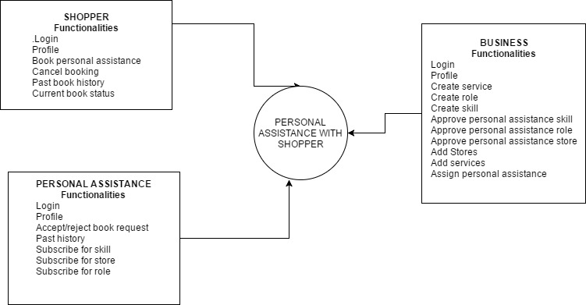

Main Functionalities of our working prototype

**Screenshots:**

**Other feature we are working on:**

1. Review system
2. Feedback system